EXPERIMENT 4
VERIFICATION OF SYSTEM PROPERTIES: LINEARITY, TIME INVARIANCE, CAUSALITY AND STABILITY
DATE: 14.06.26 OBJECTIVE
(i) To verify the linearity and time-invariance properties of continuous-time and discrete-time systems using suitable input signals and system responses.
  - To verify the linearity and time-invariance properties of continuous-time and discrete time systems using suitable input signals and system responses.
PROCEDURE
    - Select a representative CT or DT system.
    - Generate two independent test inputs.
    - Compute the individual system outputs.
    - Form a combined input and compare its system output with the corresponding linear combination of outputs.
    - Delay the input by to and compare the system response with the correspondingly delayed original output.
    - Calculate numerical differences and classify the system.
CODE
clc; clear; close all; t = -1:0.001:1;
x1 = sin(2*pi*5*t); x2 = cos(2*pi*5*t); a = 2; b = 3; t0 = 0.2;
T = @(x) 2*x;
lhs = T(a*x1+b*x2); rhs = a*T(x1)+b*T(x2);
linError = max(abs(lhs-rhs)); xDelay = sin(2*pi*5*(t-t0));

lhsTI = T(xDelay); rhsTI = T(x1);
rhsTIshift = interp1(t,rhsTI,t-t0,'linear',0); tiError = max(abs(lhsTI-rhsTIshift)); figure;
subplot(2,1,1); plot(t,lhs-rhs); grid on; title('Linearity Error');
subplot(2,1,2); plot(t,lhsTI-rhsTIshift); grid on; title('Time-Invariance Error'); fprintf('Linearity error = %g\n',linError);
fprintf('Time-invariance error = %g\n',tiError);
OUTPUT
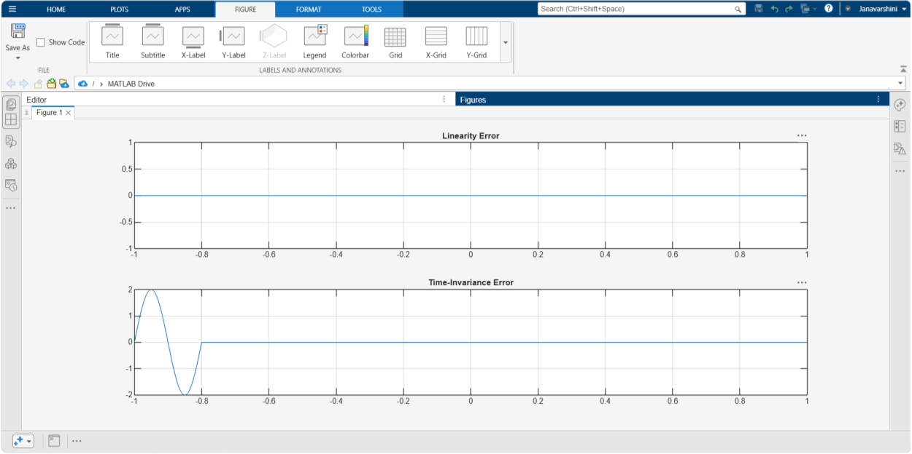
RESULT
Linearity error = 0
Time-invariance error = 2
The system properties were successfully verified and classified. Linearity, time invariance was analysed. The results confirmed the system behaviour for practical applications.

LABORATORY PERFORMANCE ASSESSMENT RUBRICS:

Objecti ve | Assessme nt Criterion | Excellen t – 4 | Good – 3 | Satisfact ory – 2 | Needs Improve ment – 1 | Weigh tage | Marks (10) | Mark s  obtai ned
(i) To | Linearity | Correctl | Applies | Performs | Unable | 20 | 2
verify | Verificati | y applies | the | a basic | to apply | 20 | 2
the | on | the | linearity | linearity | or | 20 | 2
linearit | (Homoge | homogen | tests | test (only | interpret | 20 | 2
y and | neity & | eity test | correctl | one of | the | 20 | 2
time- | Additivity | and the | y to | homogen | linearity | 20 | 2
invaria | ) | additivit | most | eity or | test. | 20 | 2
nce |  | y test (or | systems, | additivit |  | 20 | 2
properti |  | the | with | y, or only |  | 20 | 2
es of |  | combine | minor | some |  | 20 | 2
continu |  | d | errors in | systems) |  | 20 | 2
ous- |  | superpos | the | with |  | 20 | 2
time |  | ition test) | choice | noticeabl |  | 20 | 2
and |  | to every | of | e errors, |  | 20 | 2
discrete |  | CT and | inputs, | and |  | 20 | 2
-time |  | DT | algebra | needs |  | 20 | 2
systems |  | system. | or | guidance |  | 20 | 2
using |  | Chooses | compari | . |  | 20 | 2
suitable |  | suitable | son. |  |  | 20 | 2
input |  | input |  |  |  | 20 | 2
signals |  | signals |  |  |  | 20 | 2
and |  | and |  |  |  | 20 | 2
system |  | scaling |  |  |  | 20 | 2
respons |  | constants |  |  |  | 20 | 2
es. |  | , |  |  |  | 20 | 2
 |  | compare |  |  |  | 20 | 2
 |  | s the two |  |  |  | 20 | 2
 |  | response |  |  |  | 20 | 2
 |  | s |  |  |  | 20 | 2
 |  | accuratel |  |  |  | 20 | 2
 |  | y, and |  |  |  | 20 | 2
 |  | conclude |  |  |  | 20 | 2
 |  | s linear |  |  |  | 20 | 2
 |  | or non- |  |  |  | 20 | 2
 |  | linear |  |  |  | 20 | 2
 |  | correctly |  |  |  | 20 | 2
 |  | . |  |  |  | 20 | 2

 | Time-Invarianc e Verificati on (Time-Shift Test) | Correctl y applies the time-shift test, compari ng the response to the shifted input with the shifted output for every system. Handles systems with time-scaling or time-varying coefficie nts correctly and conclude s time-invariant or time-varying correctly  . | Applies the time-  shift test correctl y to  most systems, with minor errors in shifting or compari son. | Performs a basic time- shift test with noticeabl e errors (for example shifting only the input or only the output), and needs guidance  . | Unable to apply or interpret the time-invarian ce test. | 20 | 2
 | MATLA B  Implemen tation & Numerica l Verificati on | Writes correct MATLA  B code with suitable time and index vectors to generate the test inputs, the system  response s, the | Code, plots and numeric al compari son are correct, with minor errors in range, paramet ers, toleranc e or | Code runs but has noticeabl e errors in vectors, shifting or error calculati on, and needs assistanc e. | Unable to impleme nt the  tests or produce meaning ful response s and  plots in MATLA B. | 20 | 2

 |  | scaled, summed and shifted versions, and the plots.  Compute s numerica l errors between the compare d response s, and uses a tolerance to decide pass or fail.  Plots have titles, axis labels and  legends. | labellin g.
 | System Classifica tion & Mathema tical Justificati on | Independ ently classifies each CT and DT system as linear or non-linear and time-invariant or time-varying Supports each classifica tion with correct mathema  tical working | Classifi es most systems correctl y, with minor errors or limited justifica tion. | Gives basic classifica tions.  Justificat ion is incomple te or not linked to the test results, and needs guidance  . | Unable to classify the systems correctly or justify the classific ation. | 20 | 2

and with the wavefor m or
error evidence from MATLA B.
 | Engineeri ng Analysis, Record & Interpret ation | Provides a technical ly accurate interpret ation of the results and links them to the importan ce of  linear time-invariant (LTI)  systems Maintain s a  complete  , well-organize d record with code, plots, observati ons and conclusi  ons. | Maintai ns a  proper record with minor omissio ns.  Interpret ation is correct but brief. | Record and interpret ation are basic or partly incomple te, and need guidance  . | Incompl ete record, limited or no  interpret ation of the results. | 20 | 2
 |  |  |  |  | Total | 100 | 10

